**LEMBAR ASISTENSI TUGAS AKHIR**

PRAKTIKUM SISTEM BASIS DATA 2020

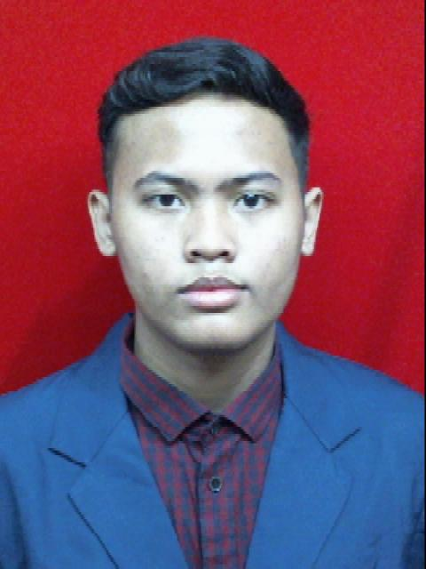

Judul Tugas Akhir : Jual Beli Akun Game

Nama Praktikan : Fathur Rahman Ar Rasyid (21120118140050)

Nama Asisten : Muslim (21120117140032)

|  |  |  |  |  |
| --- | --- | --- | --- | --- |
| **No.** | **Hari/ Tanggal** | **Jenis Asistensi** | **Keterangan** | **TTD** |
| 1. | 2 Desember 2020 | Program | ACC |  |
| 2. |  |  |  |  |
| 3. |  |  |  |  |
| 4. |  |  |  |  |

Mengetahui,

Koordinator Praktikum



Wahyu Aji Sulaiman.

21120117140019